**DESIGN PATTERNS AND PRINCIPLES**

**MANDATORY**

**Exercise 1: Implementing the Singleton Pattern:**

**Main.java:**

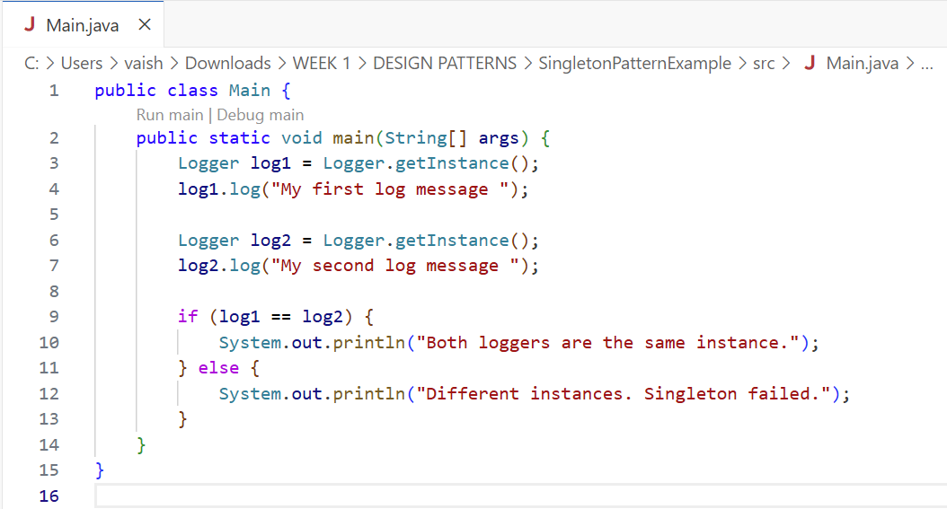

**Logger.java:**

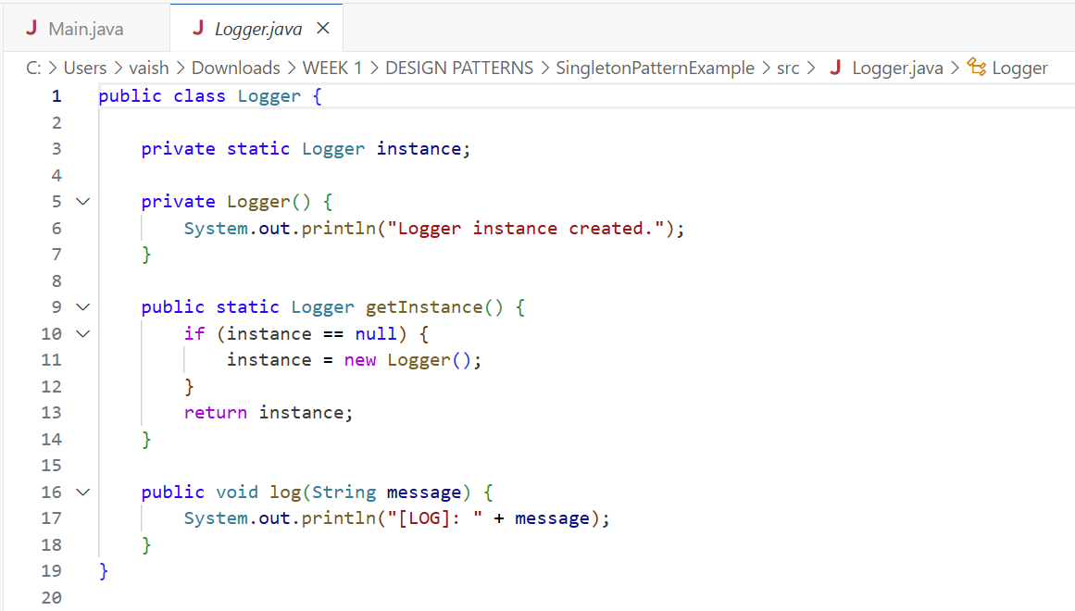

**OUTPUT:**

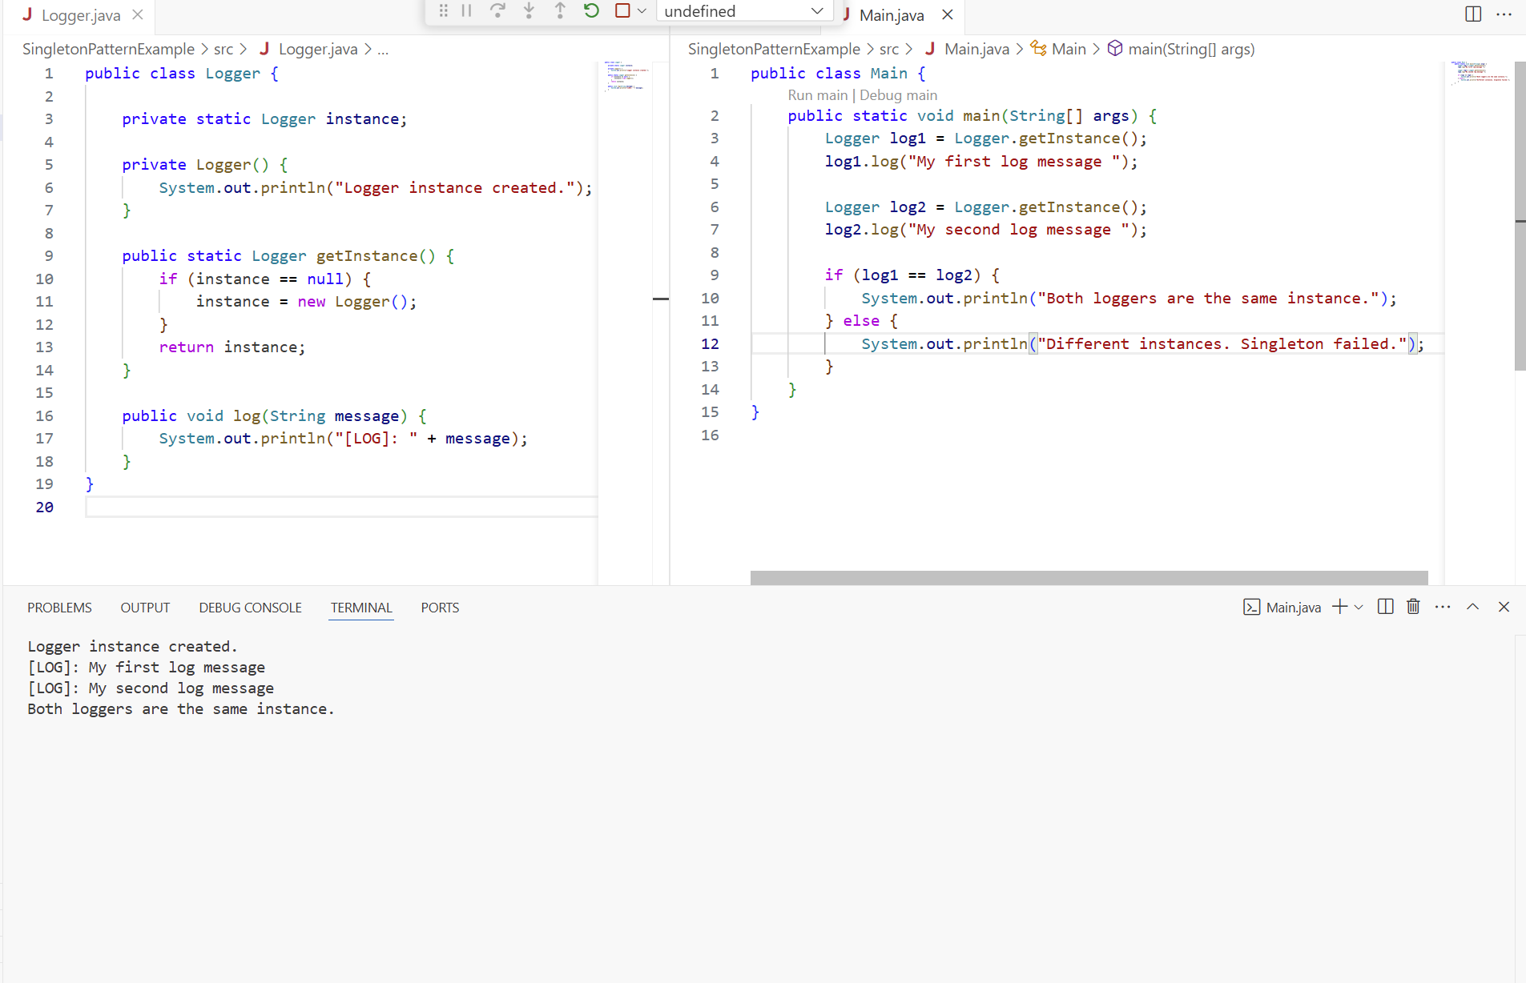

**Exercise 2: Implementing the Factory Method Pattern:**

**Document.java, DocumentFactory.java:**

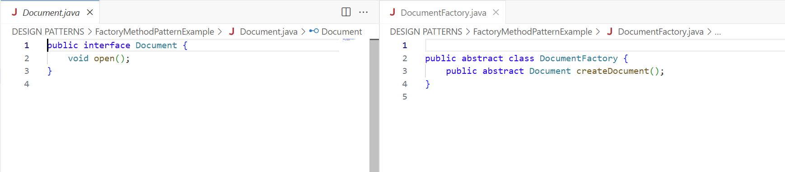

**ExcelDocument.java, ExcelDocumentFactory.java:**

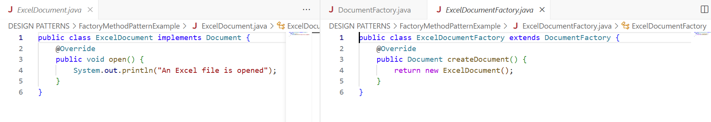

**PdfDocument.java, PdfDocumentFactory.java:**

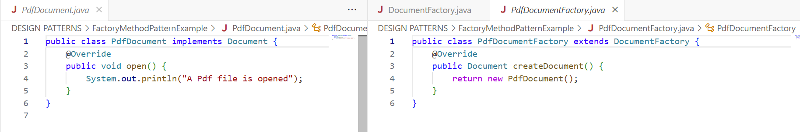

**WordDocument.java, WordDocumentFactory.java:**

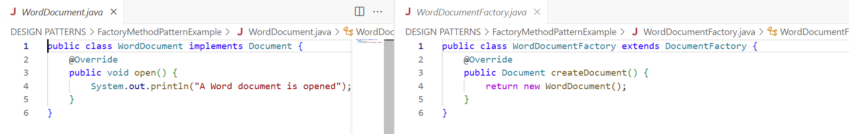

**Main.java:**

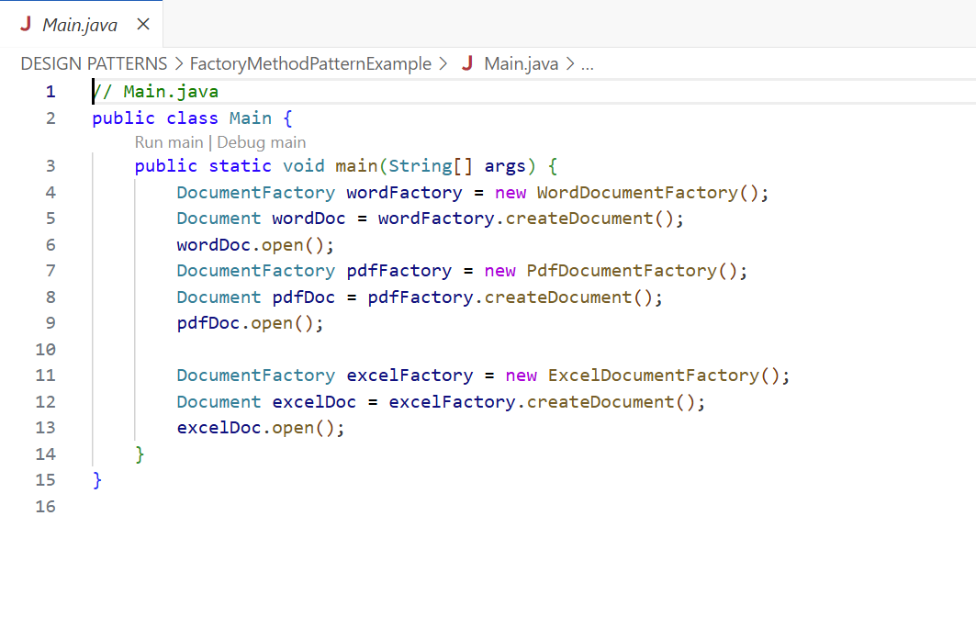

**OUTPUT:**

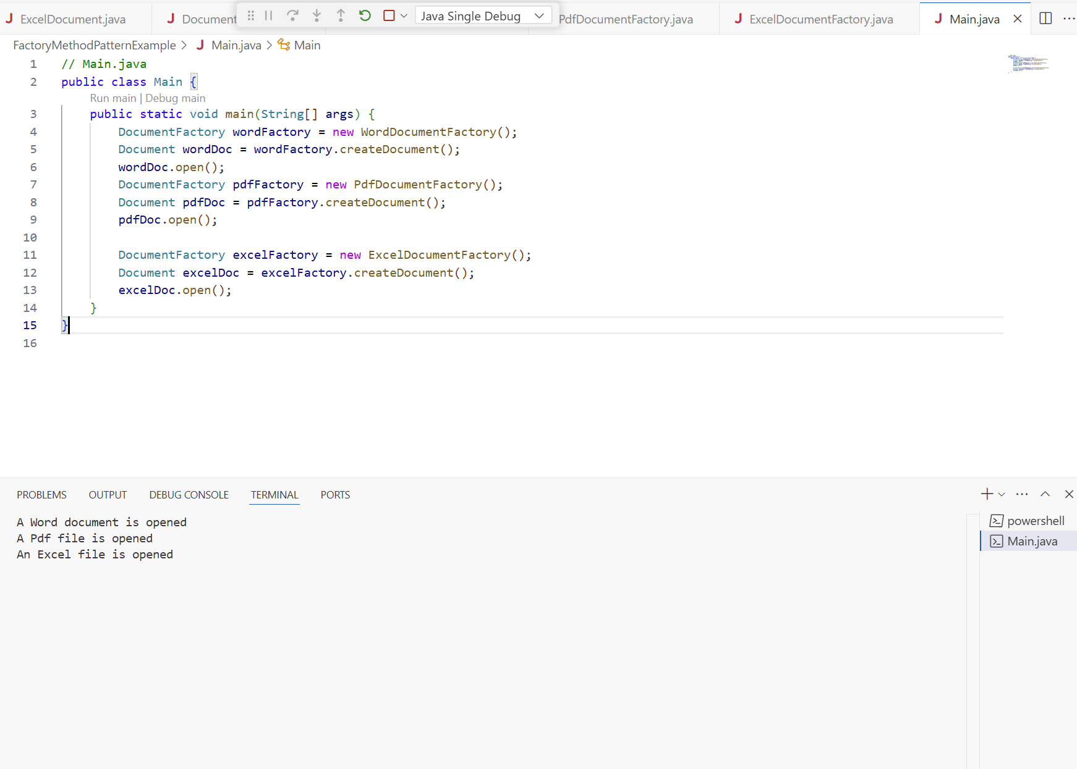

**ADDITIONAL**

**Exercise 3: Implementing the Builder Pattern**

**ComputerTest.java:**

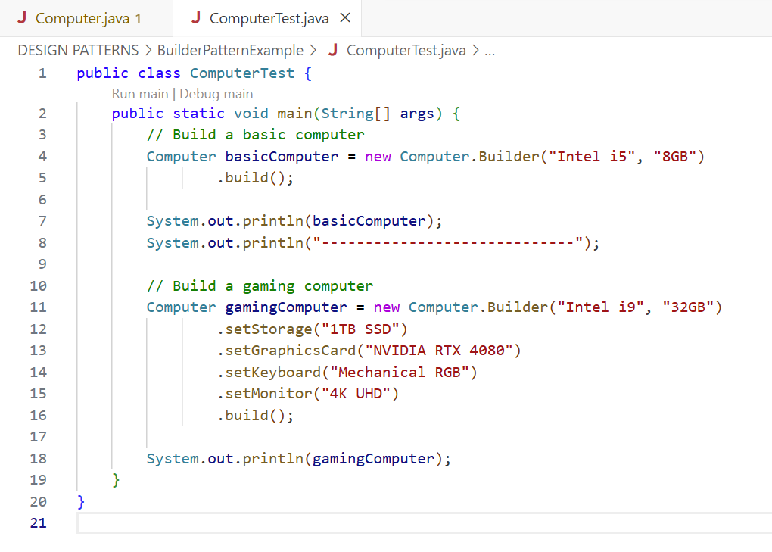

**Computer.java:**

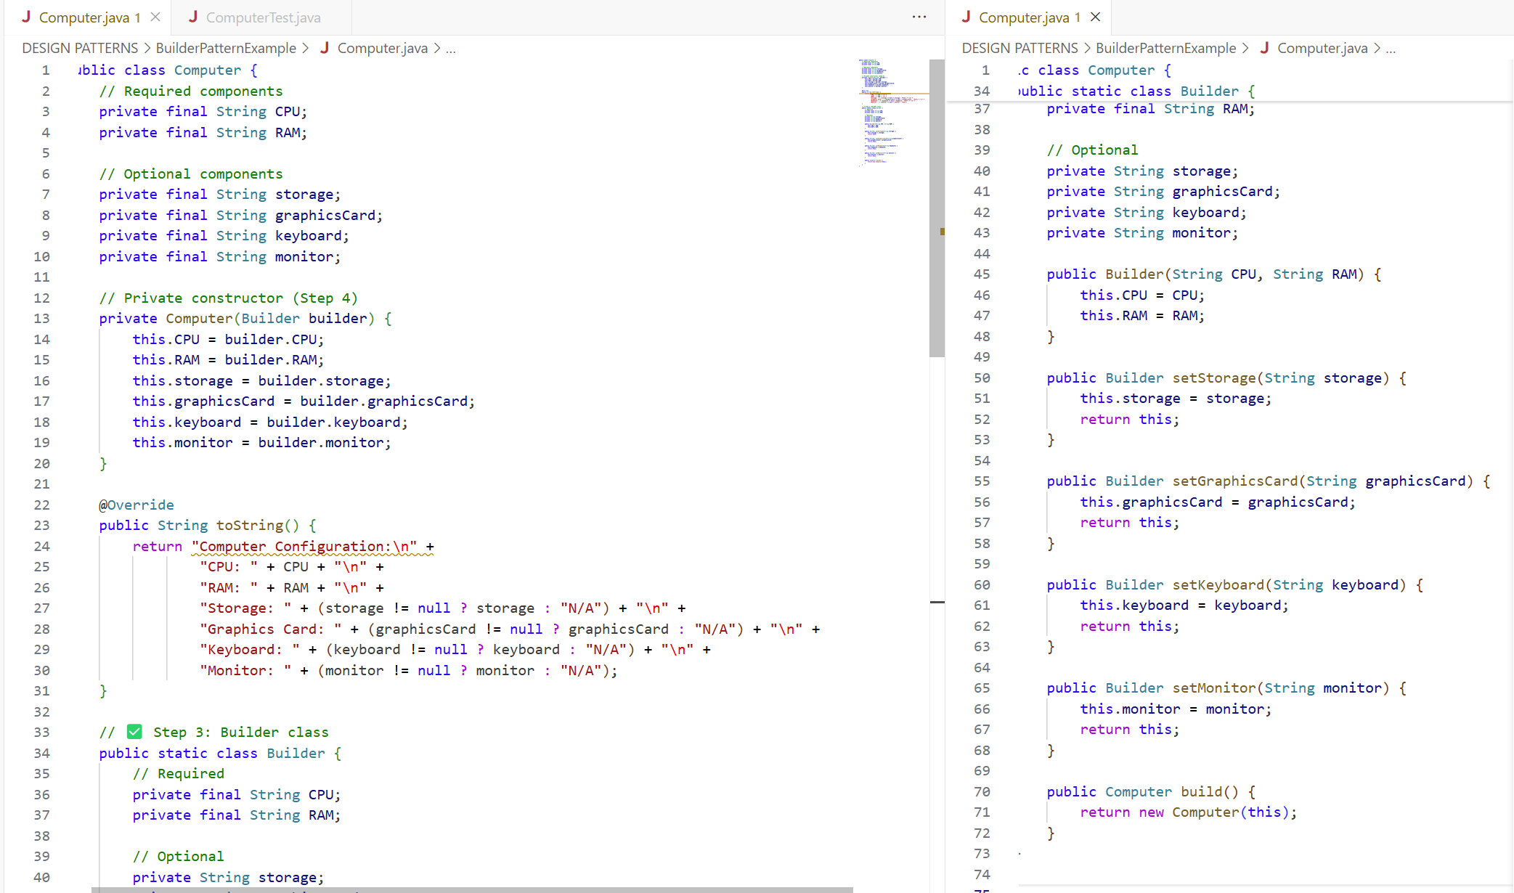

**OUTPUT:**

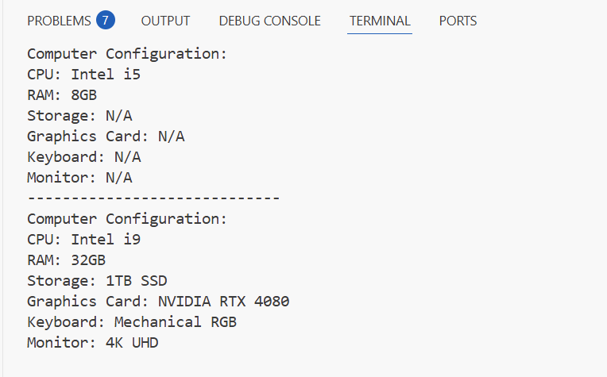

**Exercise 4: Implementing the Adapter Pattern**

**PaymentProcessor.java, PayPalAdapter.java:**

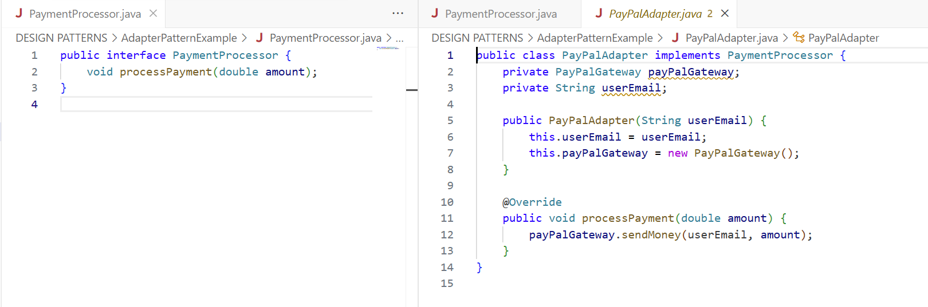

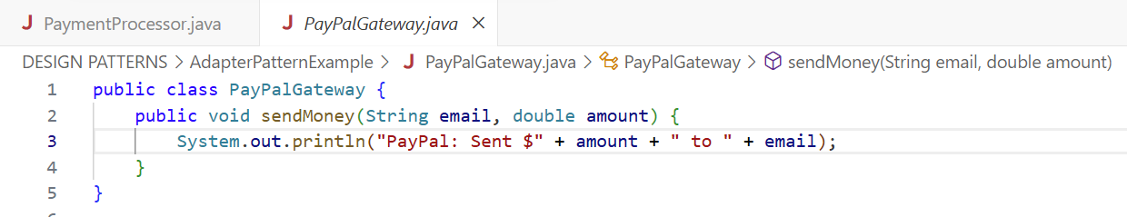

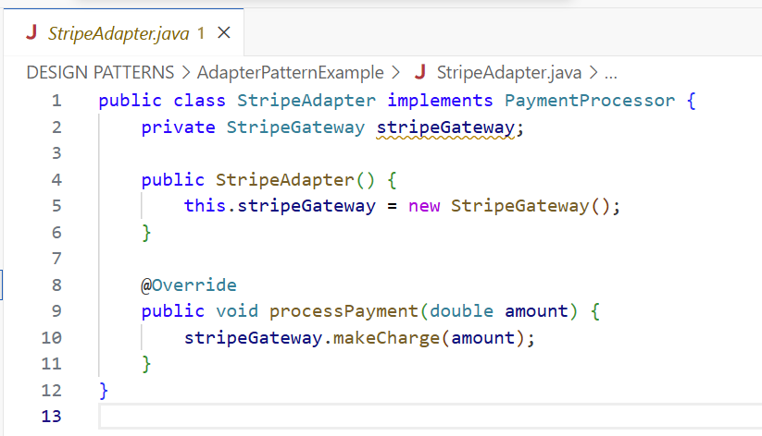

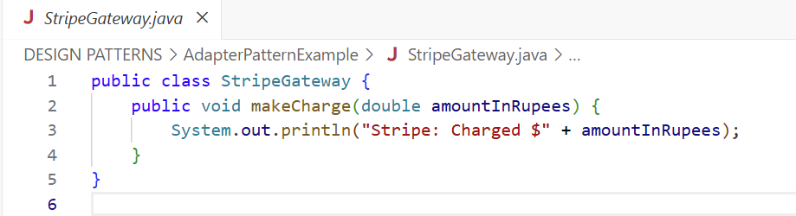

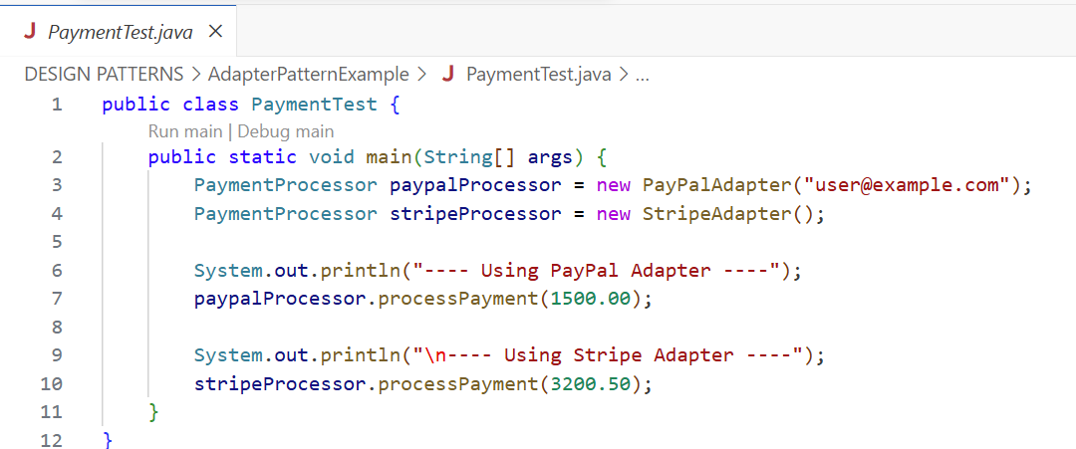

**OUTPUT:**

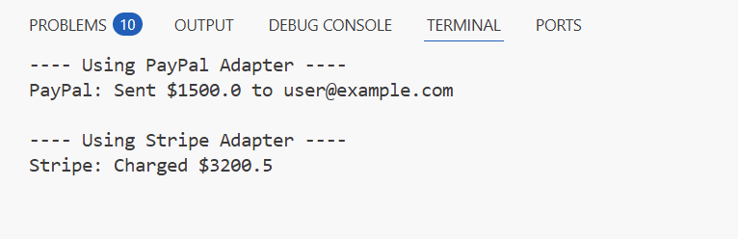

**Exercise 5: Implementing the Decorator Pattern**

**EmailNotifier.java, NotifierDecorator.java:**

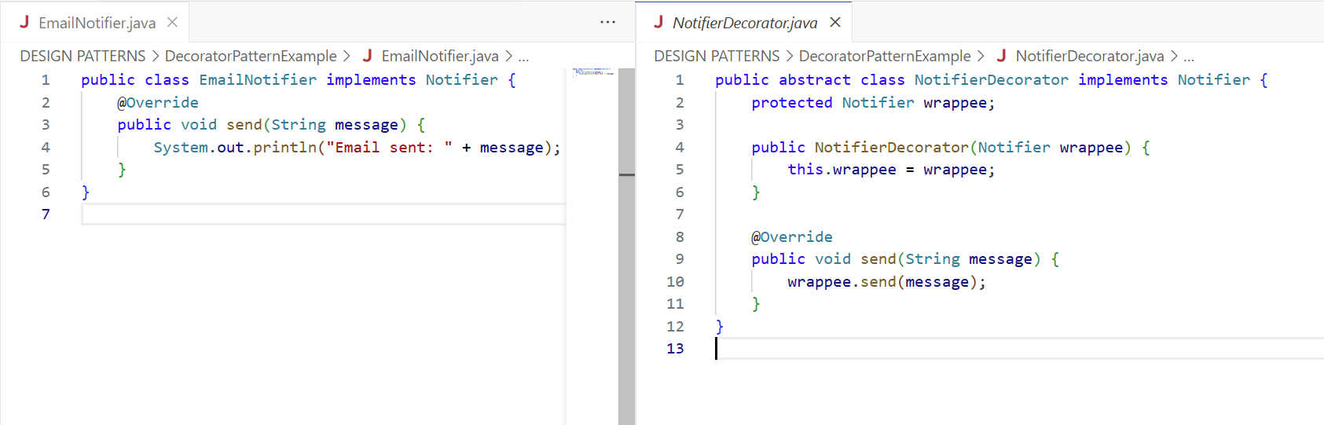

**SlackNotifierDecorator.java, SMSNotifierDecorator.java:**

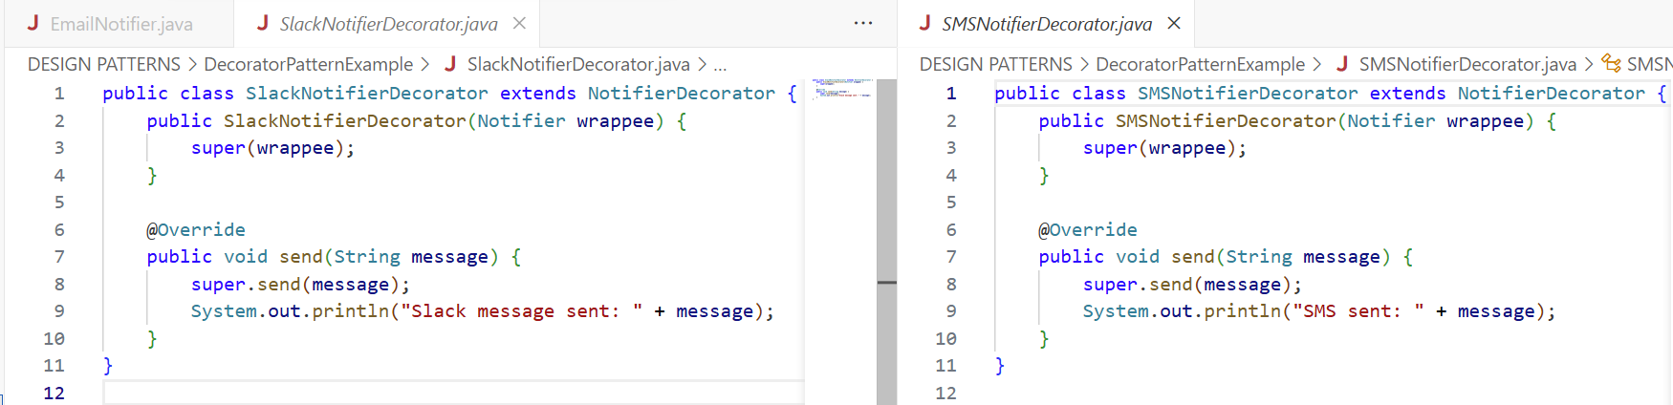

**Notifier.java. NotificationTest.java:**

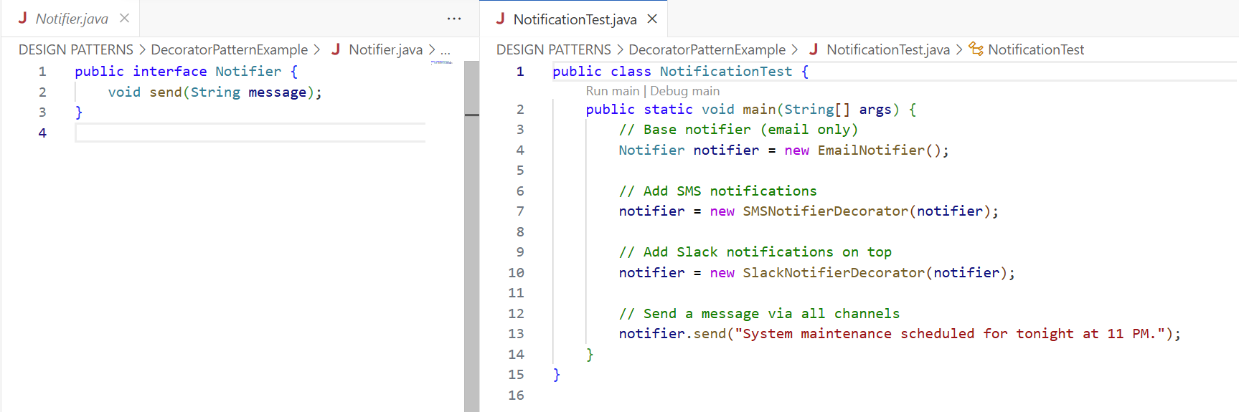

**OUTPUT:**

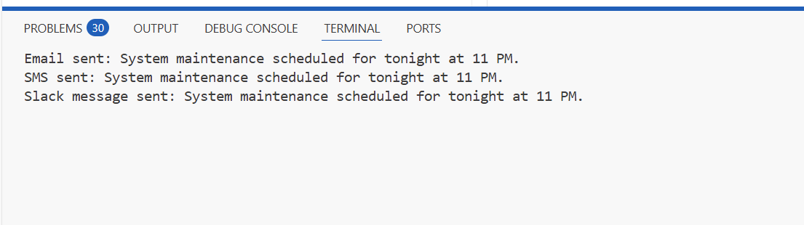

**Exercise 6: Implementing the Proxy Pattern**

**ImageViewer.java, Image.java:**

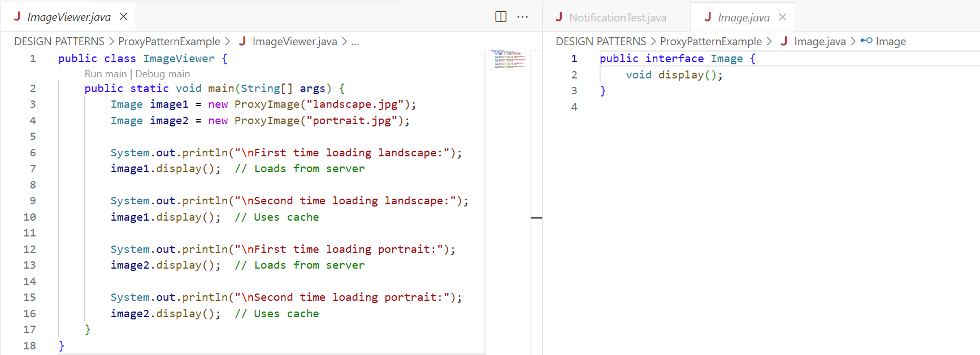

**ProxyImage.java, RealImage.java:**

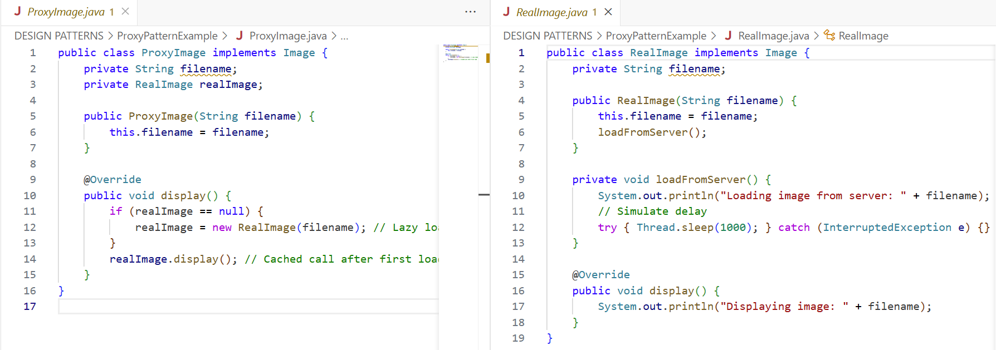

**OUTPUT:**

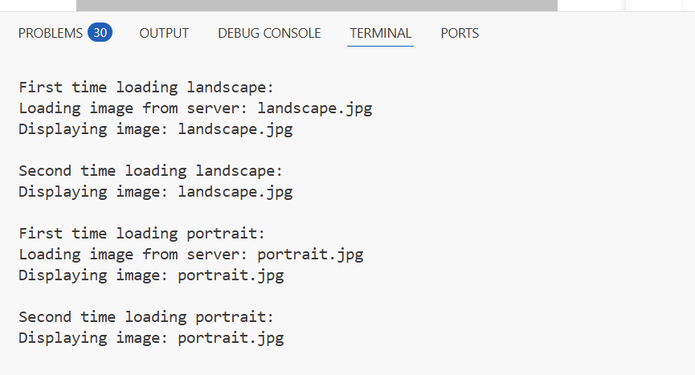

**Exercise 7: Implementing the Observer Pattern:**

**Observer.java, MobileApp.java:**

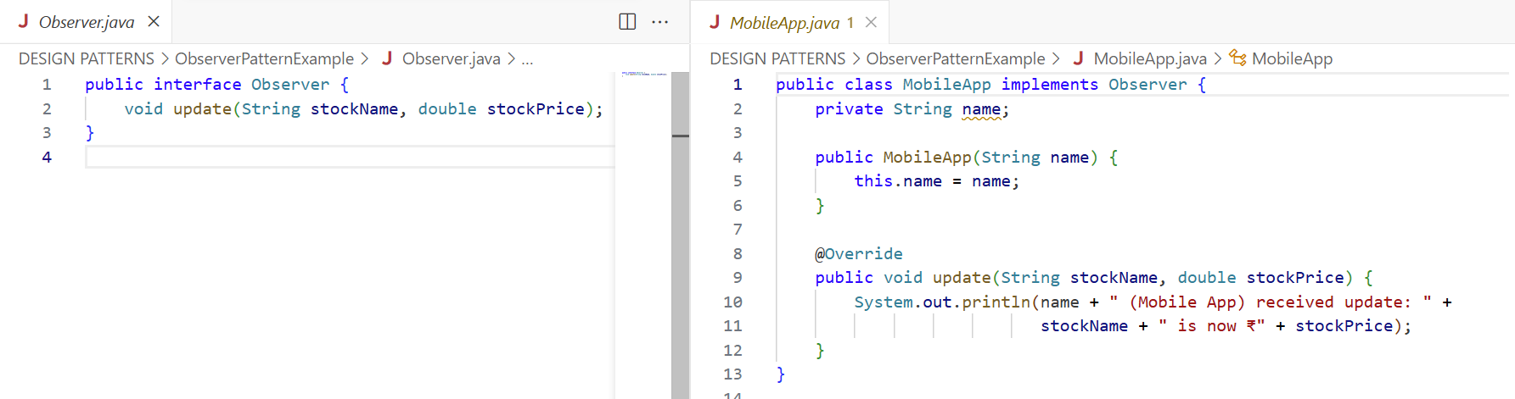

**Stock.java, WebApp.java:**

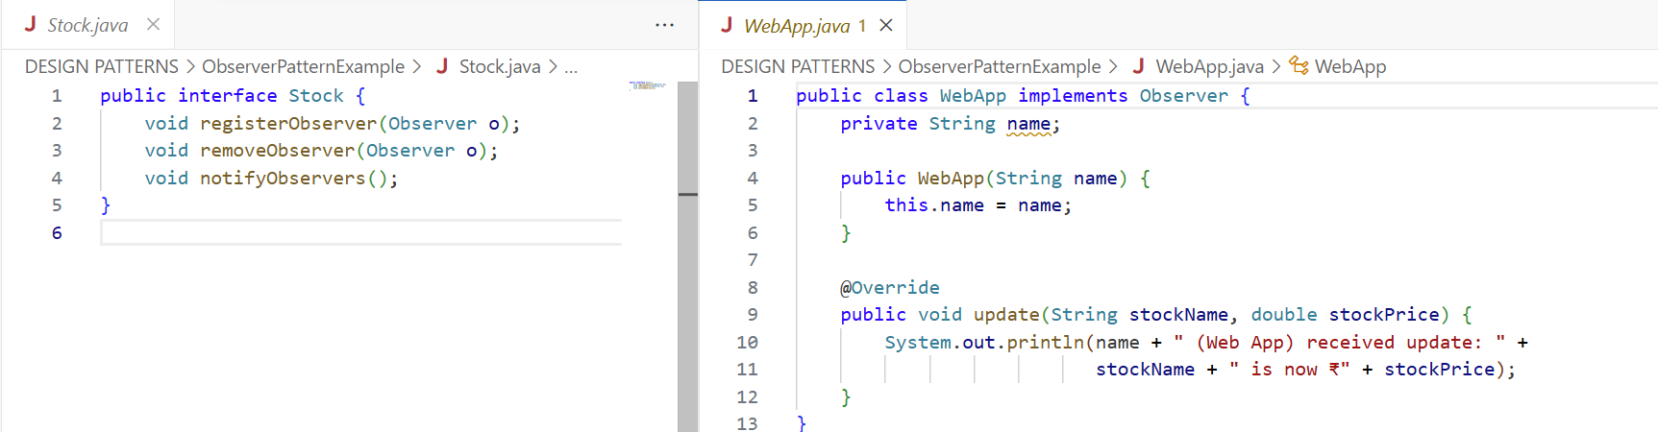

**StockMarketTest.java, StockMarket.java:**

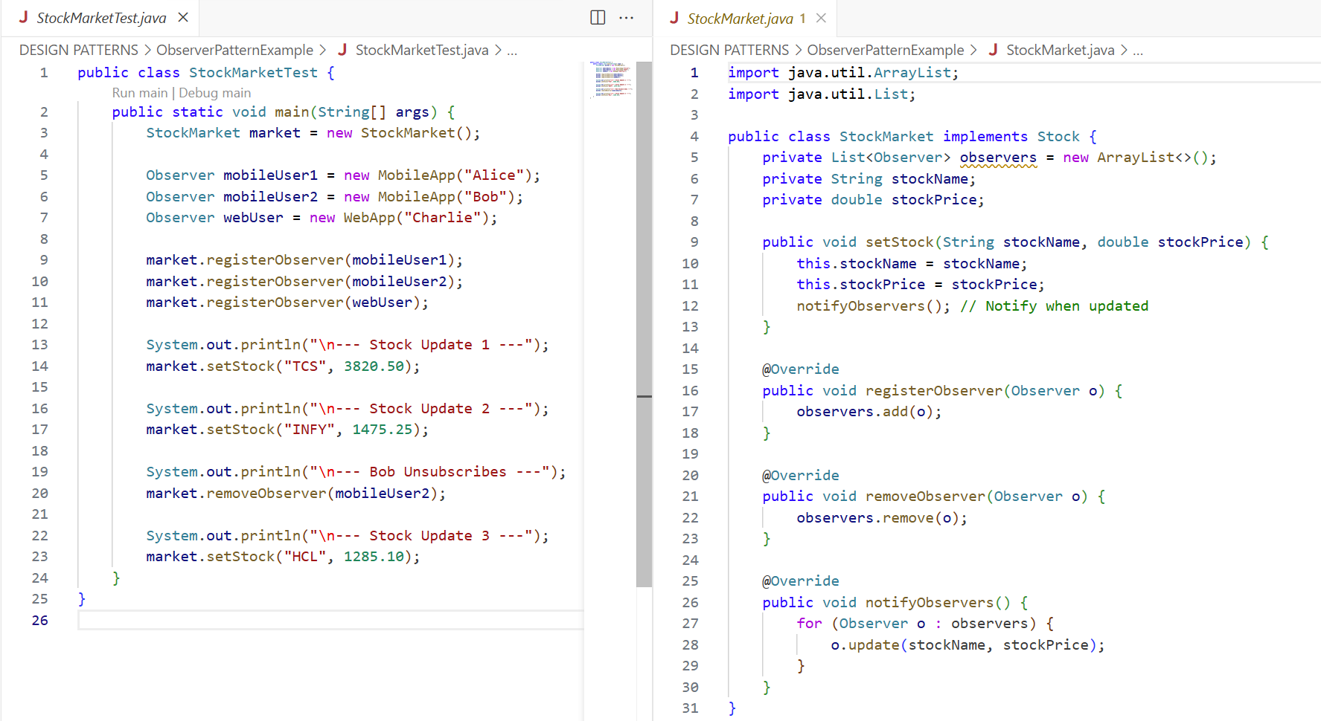

**OUTPUT:**

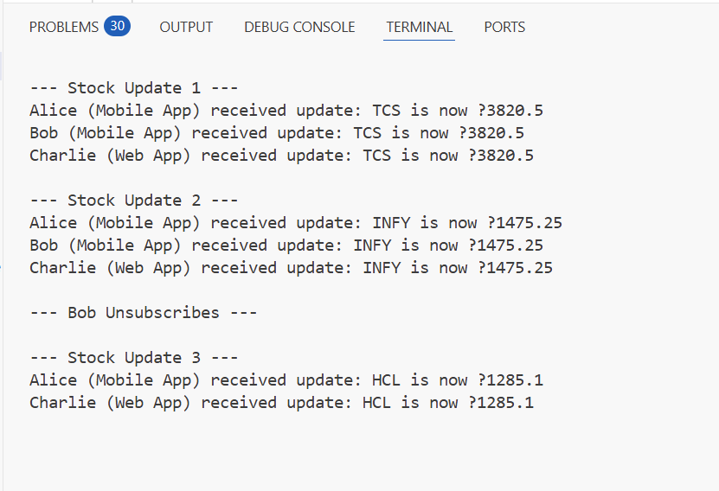

**Exercise 8: Implementing the Strategy Pattern**

**CreditCardPayment.java, PaymentStrategy.java:**

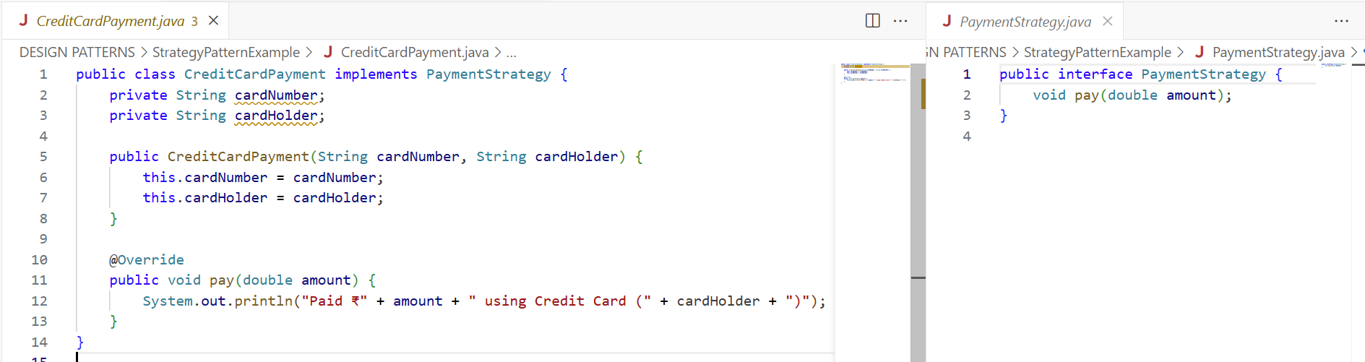

**PaymentContext.java, PayPalPayment.java**

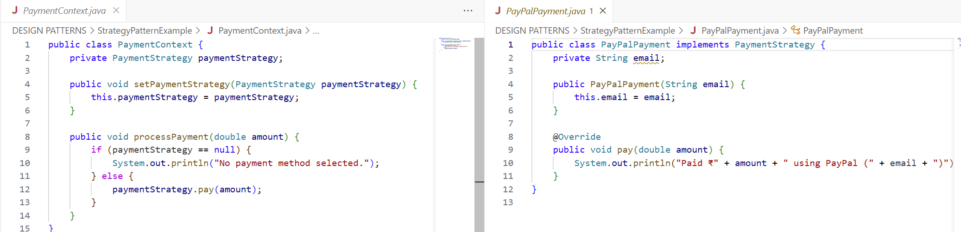

**PaymentTest.java**

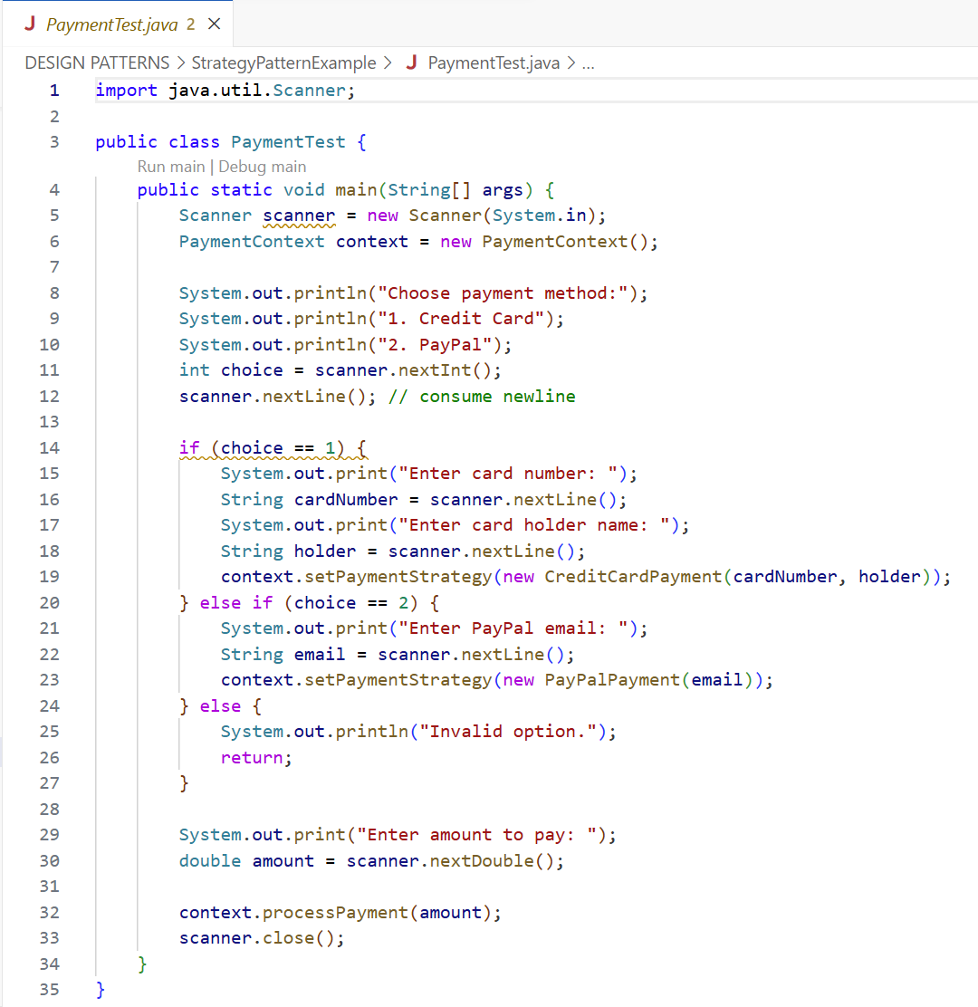

**OUTPUT**

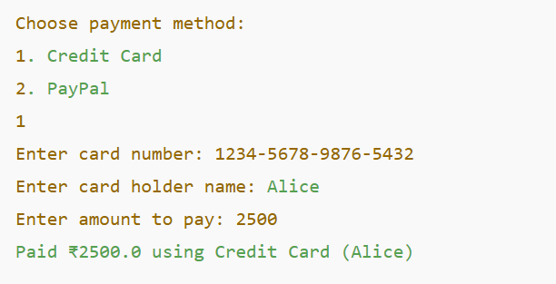

**Exercise 9: Implementing the Command Pattern**

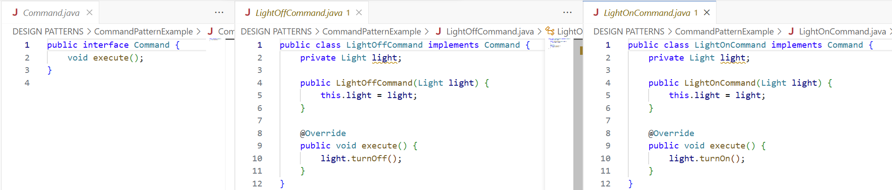

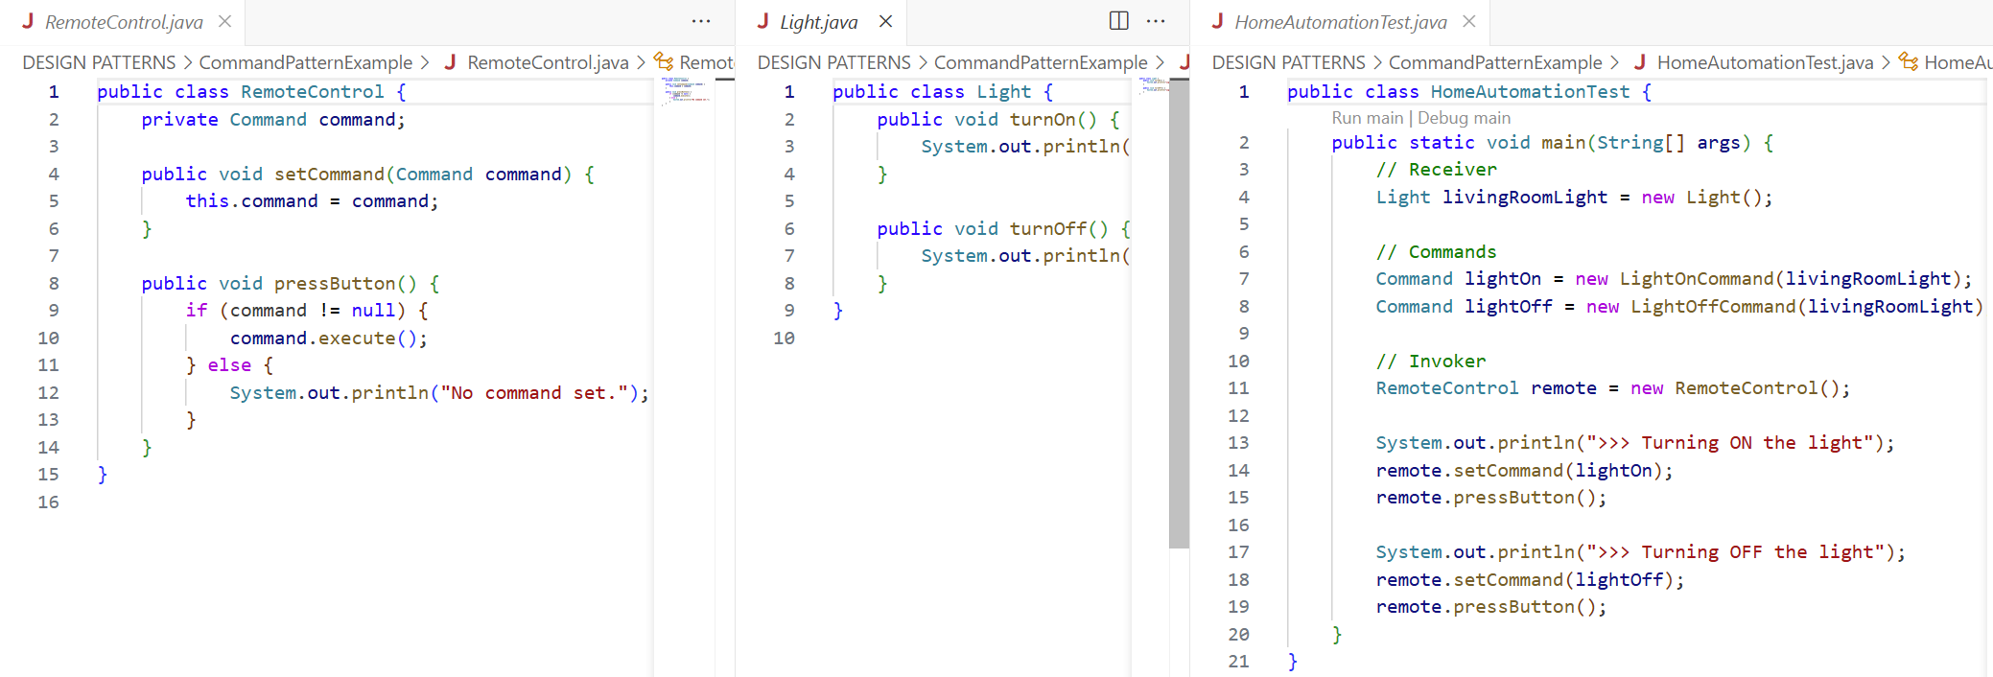

**OUTPUT**

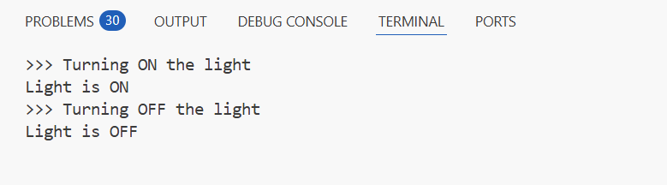

**Exercise 10: Implementing the MVC Pattern**

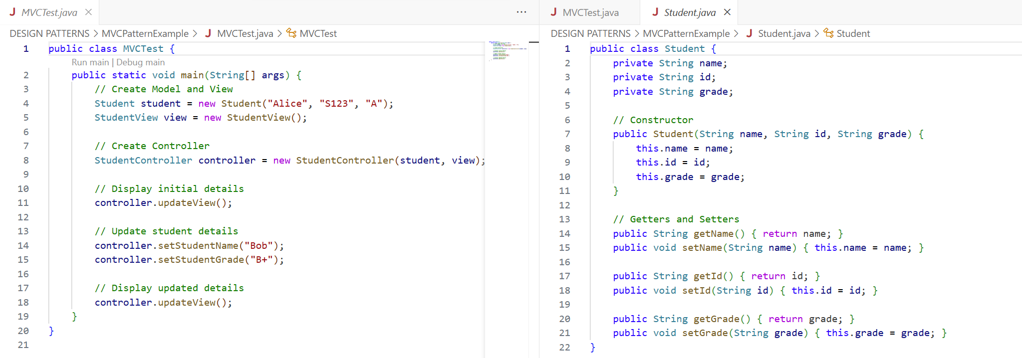

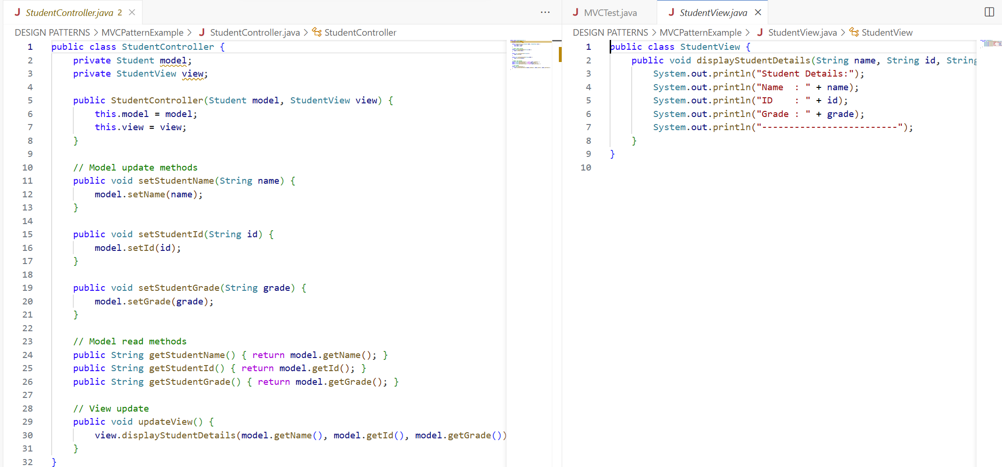

**OUTPUT**

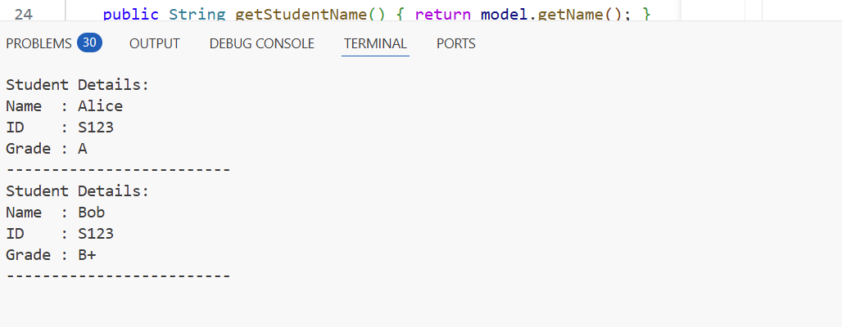

**Exercise 11: Implementing Dependency Injection**

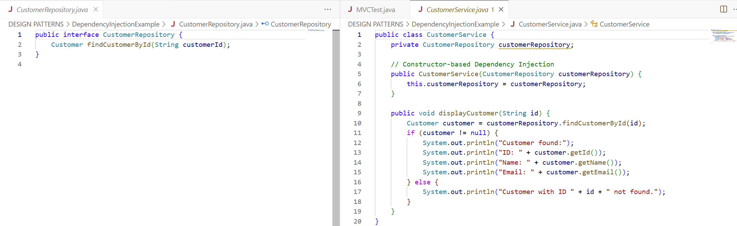

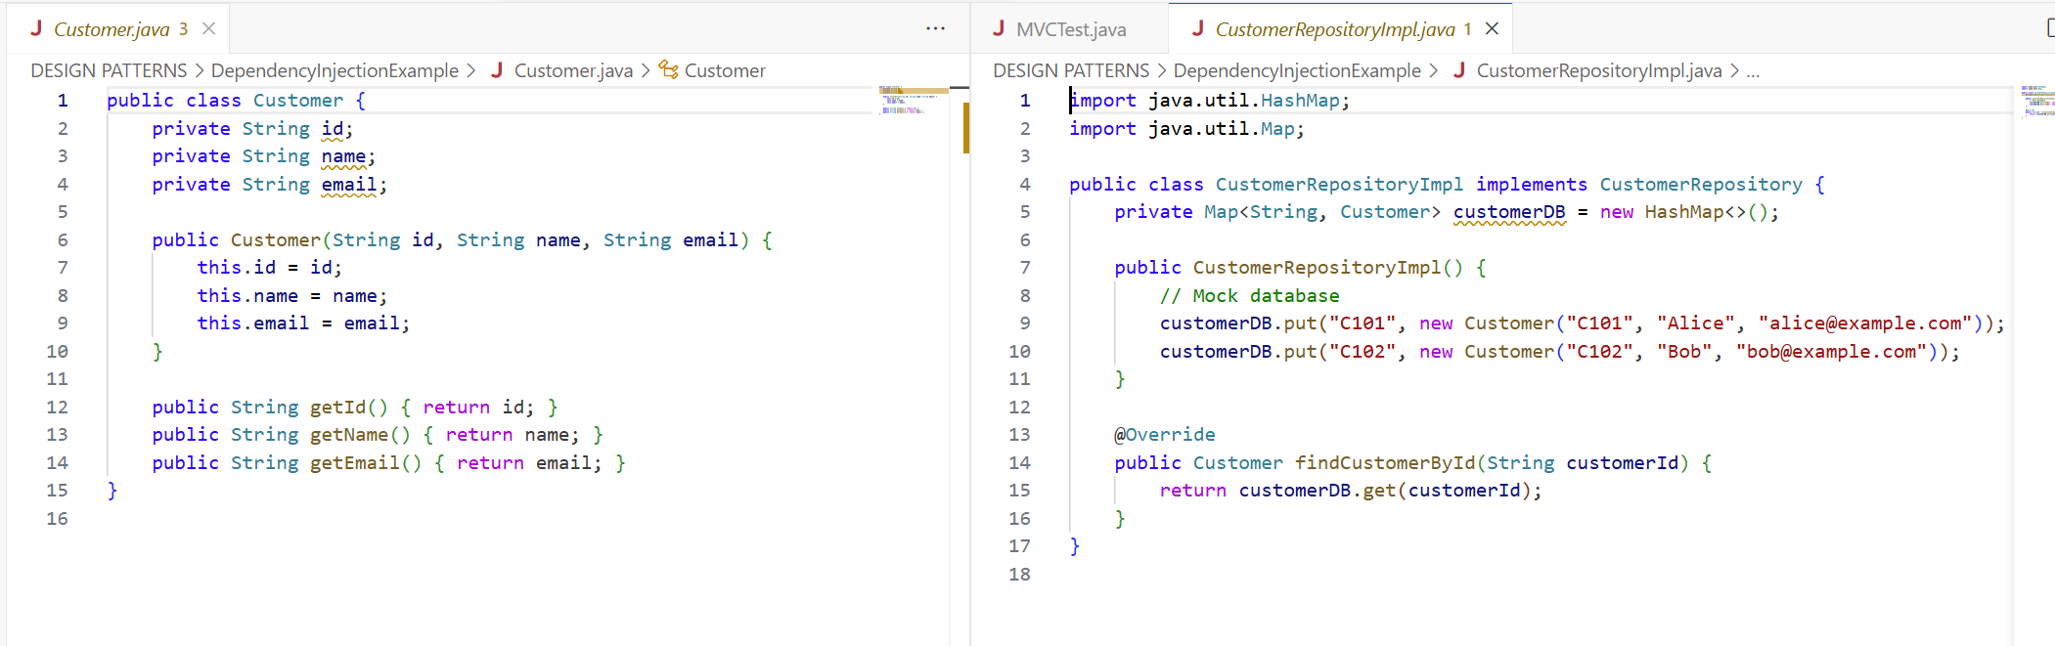

**OUTPUT**

